Assessment Task 1 - Debugging Problems

Name: Thomas Jackson  
Campus: AIE Adelaide – Game Programming

Capture a screenshot of Visual Studio running in debug mode.  
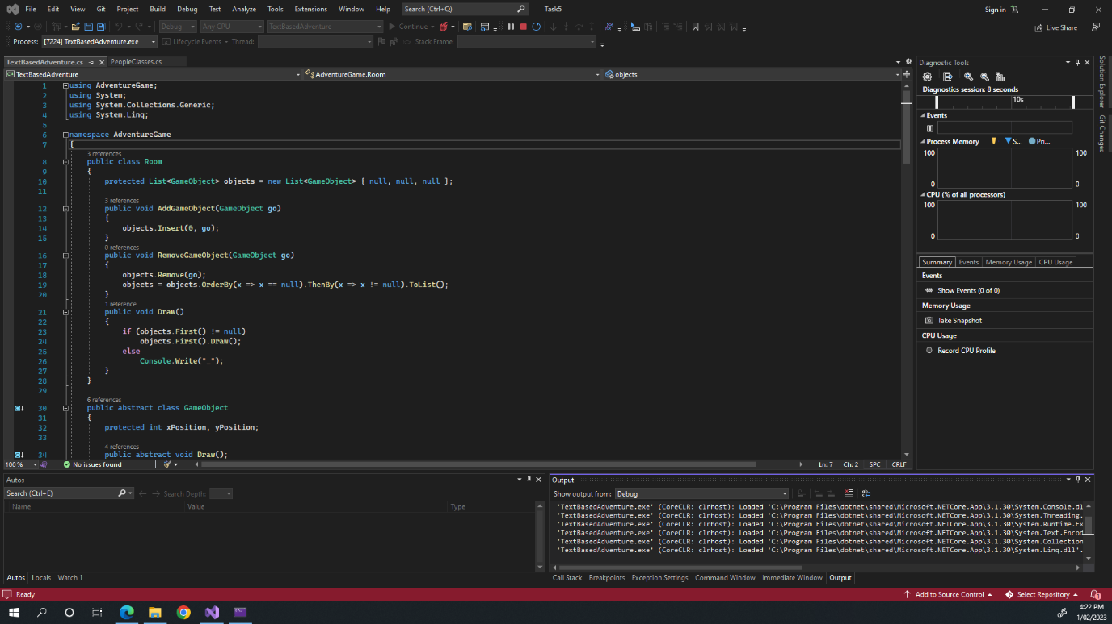

Capture a screenshot of 3 different compiler errors.  


Write a brief description (1 or 2 sentences) of what each error means.

1. Syntax Error  
   This error means that there was a typo or error in the syntax of the code, syntax being the equivalent of grammar in programming.
2. ) Expected  
   This error means that there is an open bracket ‘(‘ somewhere, usually in a function call or declaration, that doesn’t have an ending bracket ‘)’.
3. ; Expected  
   This error means that a ‘;’ hasn’t been added to the end of an expression or function call. A ‘;’ is the equivalent of a full stop in many programming languages.

List at least one website that you can use as a reference when learning C#.  
[C# docs - get started, tutorials, reference. | Microsoft Learn](https://learn.microsoft.com/en-us/dotnet/csharp/)

[C# Tutorial (C Sharp) (w3schools.com)](https://www.w3schools.com/cs/index.php)

[Stack Overflow - Where Developers Learn, Share, & Build Careers](https://stackoverflow.com/)

Capture one or more screenshots showing:

* A breakpoint  
  
* A variable watch, and  
  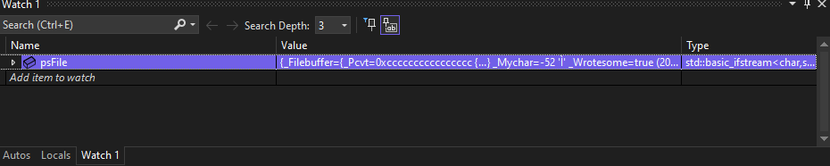
* The callstack  
  